**Kiwanis Club of [Name]  
Annual Pennsylvania Kiwanis Foundation Rose Sale**

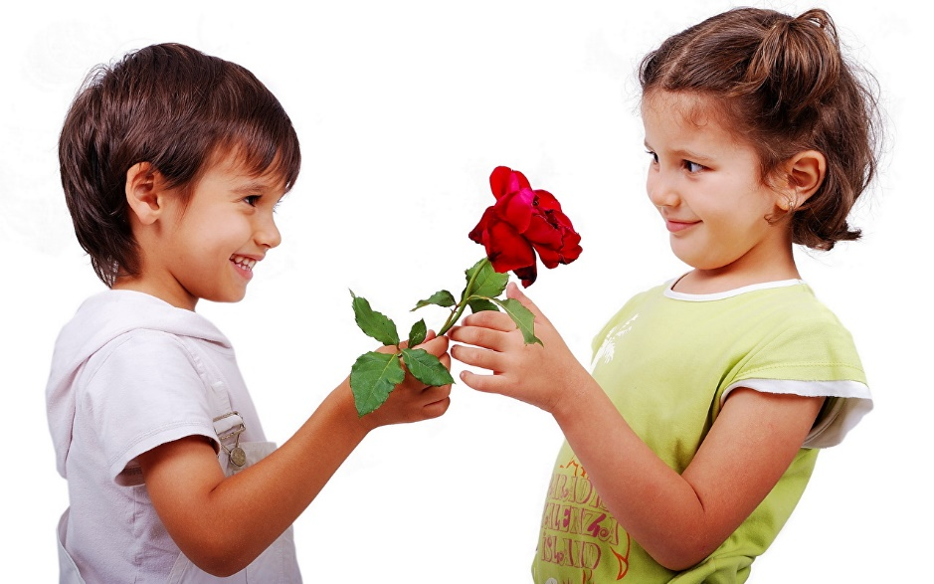Your purchase includes one dozen quality long-stemmed roses of mixed color. **Each dozen is $24** and includes tree fern and baby’s breath packaged in an attractive box that makes for a perfect gift. A portion of each sale benefits local Kiwanis community projects as well as the Pennsylvania Kiwanis Foundation’s mission of providing service grants and scholarships to youth.

• Orders may be placed until [Thursday, September 28th]

• Roses will be delivered starting Thursday, October 26th

• [Indicate here how you prefer to accept payment – cash, checks, etc…]

Club Member Name: __________________________ Phone: ____________

Total # Sold: __________ Total due of all Sales: ___________

| **#** | **Name** | **Address** | **Phone** | **# of Dozens** | **Total Due** | **Paid?**  (Yes/No) | **Payment** |
| --- | --- | --- | --- | --- | --- | --- | --- |
| **1** |  |  |  | [Delete this box before saving and printing]  Customization Notes:  Customize flyer by editing any information in the brackets [ ]  [Delete this box before saving and printing] |  |  |  |
| **2** |  |  |  |  |  |  |  |
| **3** |  |  |  |  |  |  |  |
| **4** |  |  |  |  |  |  |  |
| **5** |  |  |  |  |  |  |  |
| **6** |  |  |  |  |  |  |  |
| **7** |  |  |  |  |  |  |  |
| **8** |  |  |  |  |  |  |  |
| **9** |  |  |  |  |  |  |  |
| **10** |  |  |  |  |  |  |  |
| **11** |  |  |  |  |  |  |  |
| **12** |  |  |  |  |  |  |  |
| **13** |  |  |  |  |  |  |  |
| **14** |  |  |  |  |  |  |  |
| **15** |  |  |  |  |  |  |  |
| **16** |  |  |  |  |  |  |  |
| **17** |  |  |  |  |  |  |  |
| **18** |  |  |  |  |  |  |  |
| **19** |  |  |  |  |  |  |  |
| **20** |  |  |  |  |  |  |  |
| **21** |  |  |  |  |  |  |  |
| **22** |  |  |  |  |  |  |  |
| **23** |  |  |  |  |  |  |  |
| **24** |  |  |  |  |  |  |  |
| **25** |  |  |  |  |  |  |  |